PRESS RELEASE

Young Reporters for the Environment International Competition Winners 2016
The Young Reporters for the Environment (YRE) International Jury meeting for the 2016 Competition successfully took place on 26 May at the Foundation for Environmental Education Head Office in Copenhagen, Denmark.
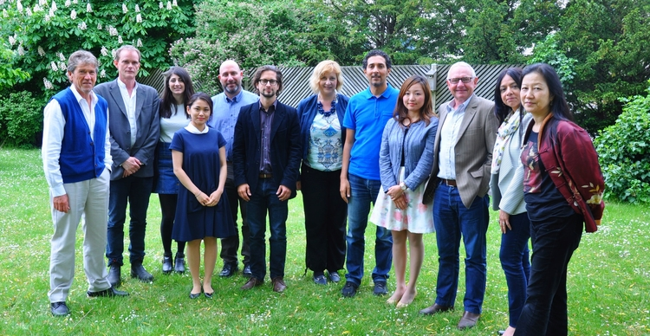
YRE International Jury 2016
The Jury was composed by stakeholders in the fields of environmental journalism and Education for Sustainable Development. The members, as of May 2016, are Christopher Slaney, freelance journalist, Mari Nishimura, Associate Programme Officer, UNEP, Julie Saito, Programme Specialist of Communication, UNESCO, Clemens Bomsdorf, journalist and correspondent for the Nordic countries, Torvald Jacobsson, Founding Director of TheGoals.org, Amine Ahlafi, FEE Board of Directors member, responsible for YRE, and Anne Vela-Wagner, Representative of the Wrigley Company Foundation. You can find more information on their profiles here.
The Jury went through and discussed the top national entries in the media categories of articles, photographs and videos, across the age categories 11-14, 15-18, 19-21, as well as the new category; International Collaboration. The Jury then decided on this year's YRE International Competition winners, who will be shortly receiving prizes and distinctions for their entries. All entries can be found on the competition's Exposure page.
Here is a general comment from the Jury members;
The members of YRE International Jury appreciated this year’s submissions for the YRE International Competition. The Jury members are especially impressed with the quality of submissions in younger age categories. Some of the submissions from younger age categories are well-made in terms of composition, structure, and technics. The Jury members also appreciated the submissions for the new category; International Collaboration. The Jury members hope to see more of this collaboration between students and youths in different countries.
The each first place winner will receive a prize of a laptop, camera or video camera according to the media category. The winning entries will also be published on Huffington Post kids as a prize.
The winners for 2016 are:

Article

11-14 years old
1st Place
Title: Not to bee put aside
Author: Lovisa Kjell, Hildur Eriksson (Sweden)
"A very interesting approach. It is a wonderful piece with a great cover photo and a good ESD (Education for Sustainable Development) story. "
2nd Place
Title: Now You See It, Now You Don’t: Plastic Pollution Near and Far
Author: Sarah Goodstadt (Canada)
2nd Place
Title: Save Ksar El Kebir Gardens!
Author: Khadija Soussi, Omar El Bakri, Ghizlan Lanaya, Fatima Boudich, Khaoula Loumi and Zakaria Saydi (Morocco)

15-18 years old
1st Place
Title: Green Roofs – A new life to city’s monotony
Author: Angelina Grom’yak, Maria Cruz, Diogo Marques, Rodrigo Mateus, Pedro Barreira, Bárbara Machado (Portugal)
"It is well-researched and well-written with good amount of data."
2nd Place
Title: Coffee Pods - a Modern Trend or an Environmental Risk?
Author: Patrícia Beličková (Slovakia)
3rd Place
Title: Metempsychosis in a dustbin
Author: Marie Pouillaude (France)

19-21 years old
1st Place
Title: Clean water is the source of our lives
Author: Andrijana Arsić (Serbia)
"A good approach to the topic, and it shows the actual engagement. Interested in the implementation of actual actions."
2nd Place
Title: Impact of our railways
Author: Joana Pedro (Portugal)
3rd Place
Title: A Waste paper… a Lost Tree
Author: Ilham Derrez, Haitham Fathi, Ouiam Zeaimi, Wijdane Jouhari, Soukaina El Aouni, Diaeedine Dahmouch (Morocco)

Photograph

11-14 years old
1st Place
Title: Surprising and unexpected finding
Author: João Pedro Paour Carvalho (Portugal)
"It shows the effort to understand the problem, and the story is good and well-connected to the picture. The picture is beautiful. "
2nd Place
Title: Guilty Conscience
Author: Julia Scerri (Malta)

15-18 years old
1st Place
Title: "I live today hoping for a better tomorrow"
Author: Sonia Miheş (Romania)
"A great photo, horizon at an angle, smoke stack over shoulder, hands in pockets. It is a symbolic and eye-catching picture, and it delivers a strong message."
2nd Place
Title: Returned to sender by the waves!
Author: Kurt Micallef (Malta)
3rd Place
Title: We are Killiing Ourselves
Author: Lukáš Krnčok (Slovakia)

19-21 years old
1st Place
Title: Companionship
Author: Xue Fan (China)
"A nice and strong photo. Eye-catching."
2nd Place
Title: The Last Call
Author: Ouijdane Chahdi, Mohamed Lwardi (Morocco)
3rd Place
Title: Gardens Bloom Once a Year…
Author: Irina Gavrilova (Kazakhstan)

Video

11-14 years old
1st Place
Title: Energy in water
Author: Ana Daniela Silva, Bruna Silva, Inês Rodrigues (Portugal)
"A great story and well-told. Reporters managed to view the issue objectively, particularly by pointing out what improvements are still lacking, while addressing the environmental benefit of this means of transportation."
2nd Place
Title: “Tale of ant and elephant”
Author: MUSTAFA EMİR KAYA, OĞUZ TOPAL, BARKIN CANOĞULLARI, BATIN GÖRKEM ÇOLAK, AZRA PEKGÖZ, ELİF NİSA BOYRAZ, BUĞRA MACUNCU, BİYÇE KORKMAZ, GÜLÇİN DİNÇ, CEYLİN AKIN (Turkey)
3rd Place
Title: Trees in Nová Dubnica
Author: Mária Jánošíková, Tamara Eliášová, Michal Mazánik (Slovakia)

15-18 years old
1st Place
Title: Bready steady sort in Blaise Pascal High School
Author: Axel Heitz-Retamal, Emma Plisson, Clémence Borgard, Eglantine Meriau, Delphine Millard, Damien Mouveau (France)
"A great story, many different elements but all interconnected. Good approach and it works well. Nice camera work and unique ending which makes this piece original."
2nd Place
Title: Collect Cooking Oil and Make a Difference
Author: Matej Majerský, Patrik Štefík (Slovakia)
3rd Place
Title: Plastic Pollution
Author: Mymoon Bhuiyan (Canada)
3rd Place
Title: One day as an environmental crook
Author: David Norberg, Elias Vernersson, Maja Jonsson, Julia Portin (Sweden)

19-21 years old
No winners

International Collaboration
Honourable mention
Title: Bicycle: the vehicle for sustainable mentality
Author: Maria Carreira, Sharad Poudel, Martim Teixeira, Rita Costa, Kyriaki Hadjichambi, Katerina Papamiltiadous (Cyprus and Portugal)
"Good research and arguments from different perspectives are described."

The meeting concluded with a fruitful conversation on the developments in Young Reporters for the Environment and how the programme and the competition itself can evolve in the future.

All yre entries….

https://yrecompetition.exposure.co/

